BTECHCSE705T Project Synopsis
On
SmartLearn – an ai based memory booster

Submitted to Rashtrasant Tukadoji Maharaj Nagpur University, Nagpur in partial fulfillment of requirement for the award of the degree of
BACHELOR OF TECHNOLOGY
In
Computer Science & Engineering

Submitted By
Tejal K. Kawale | Shreya G. Kohad
Vaishnavi D. Ughade  Shravani S. Dudhbade | Tejal G. Tijare

Under the Guidance of
Dr. Shrikant Zade
Head Of Director

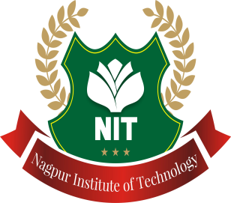

Department of Computer Science & Engineering
NAGPUR INSTITUTE OF TECHNOLOGY
Mahurzari, Katol Road Nagpur-441501
Rashtrasant Tukadoji Maharaj Nagpur University, Nagpur
2025-2026

